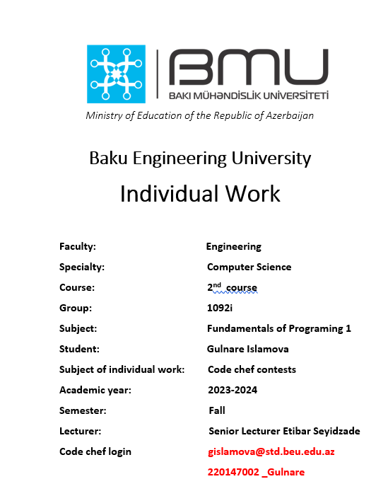

STARTERS 102 DIVISION 4(RATED)

1.SPORT SECTION

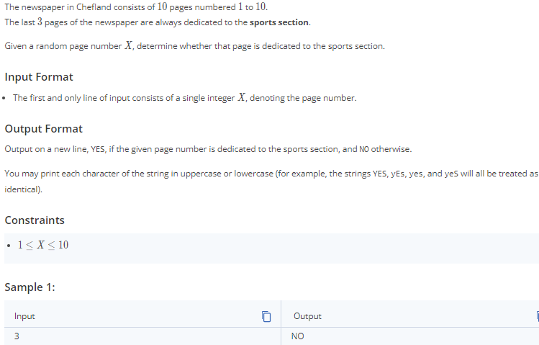

SPORT SECTION:

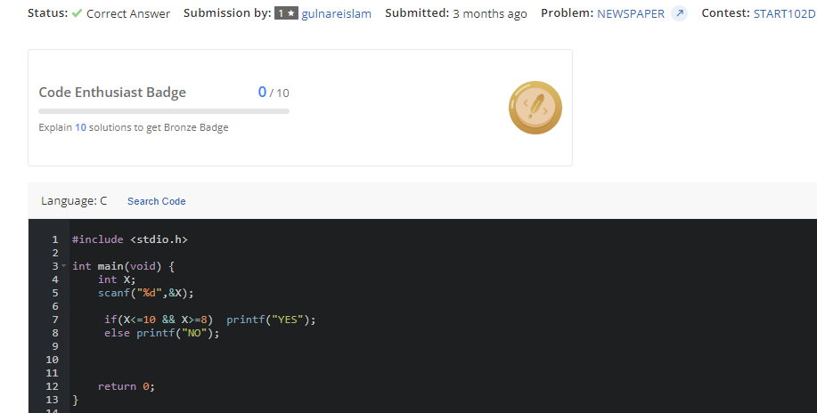

STARTERS 103 DIVISION 4(RATED)

2.OCTOBER MARATHON

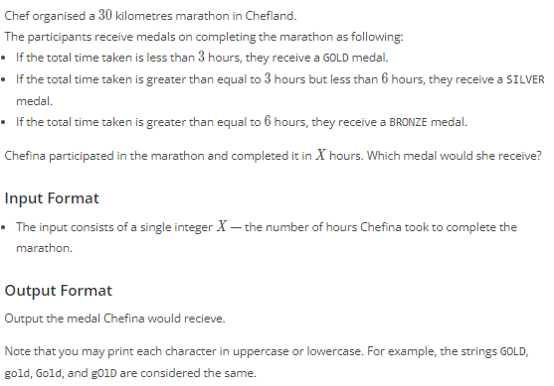

OCTOBER MARATHON

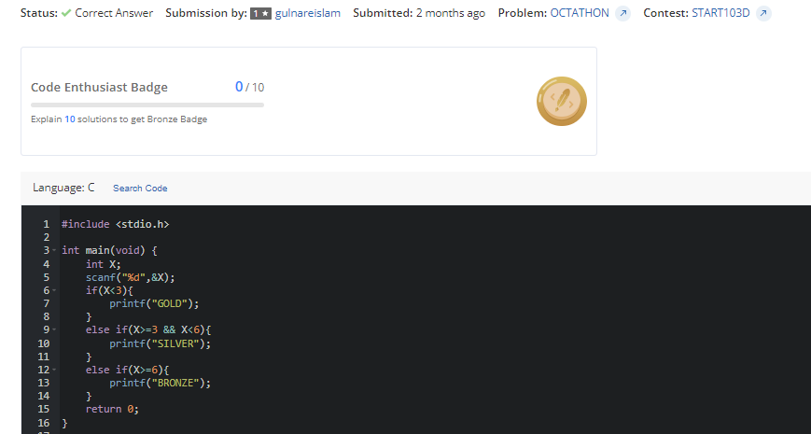

STARTERS 104 DIVISION 4(RATED)

3.PIZZA CUTTING

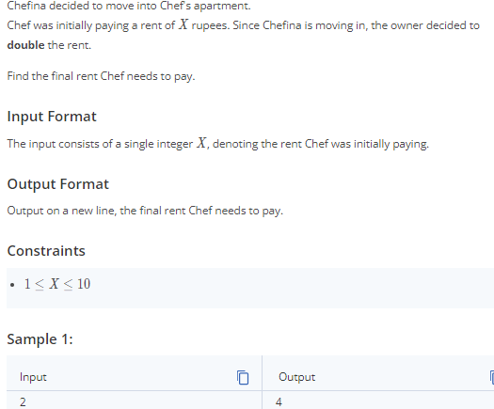

PIZZA CUTTING

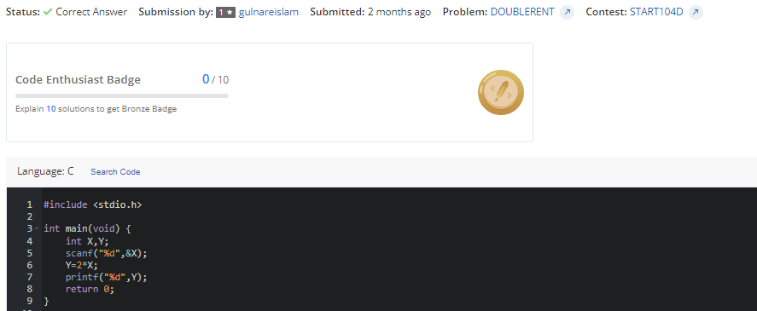

STARTERS 104 DIVISION 4(RATED) 4.DOUBLE RENT

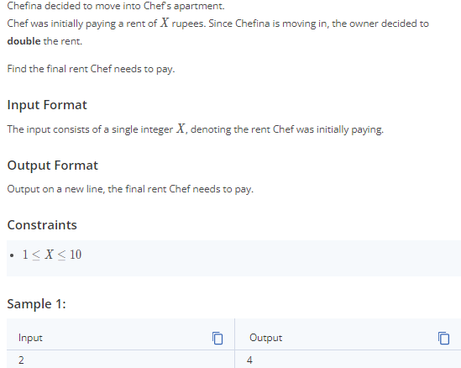

DOUBLE RENT

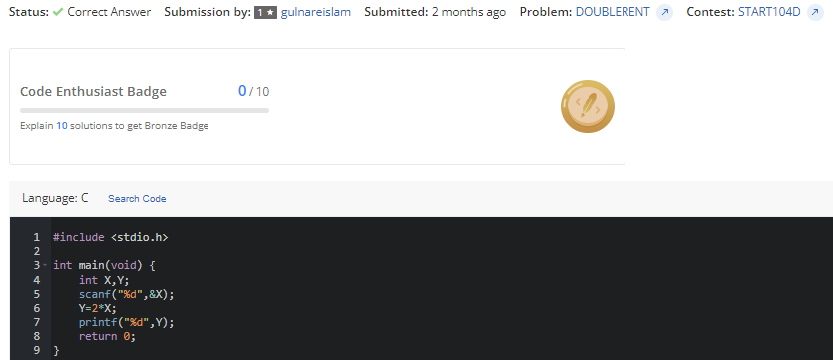

STARTERS 105 DIVISION 4(RATED) 5.BONE APPETIT

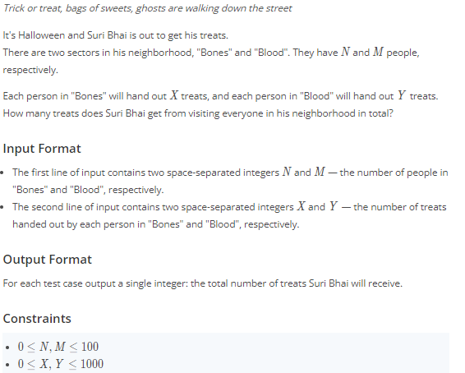

BONE APPETIT:

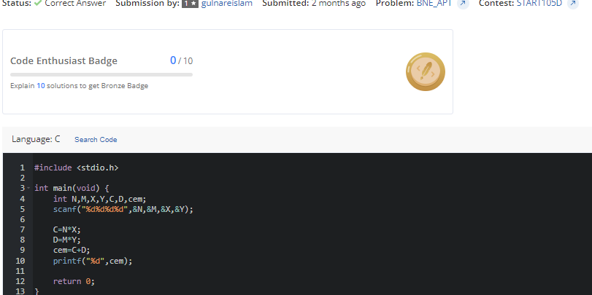

STARTERS 106 DIVISION 4(RATED) 6.FAN POLL

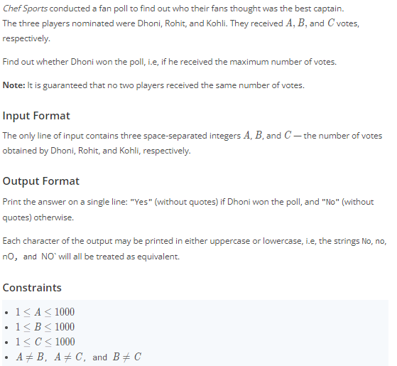

FAN POLL:

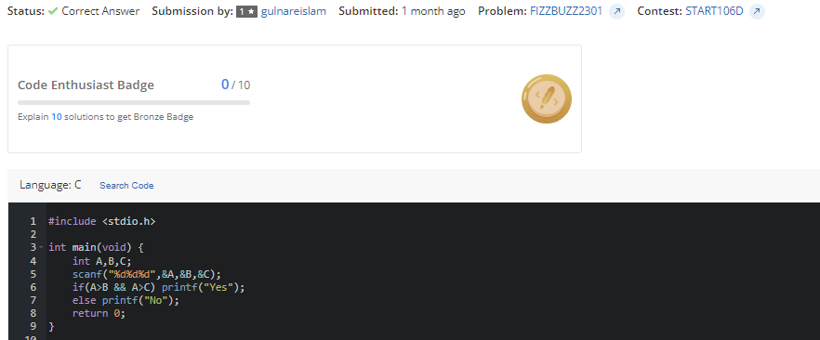

STARTERS 107 DIVISION 4(RATED) 7.CLEAR DAY

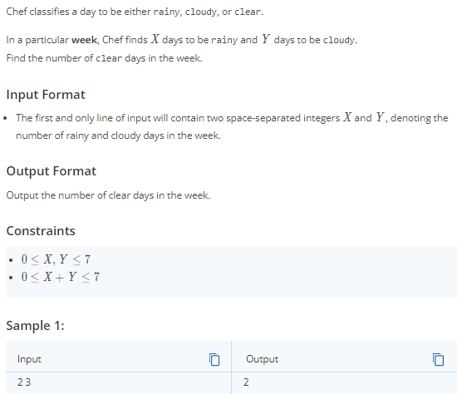

CLEAR DAY:

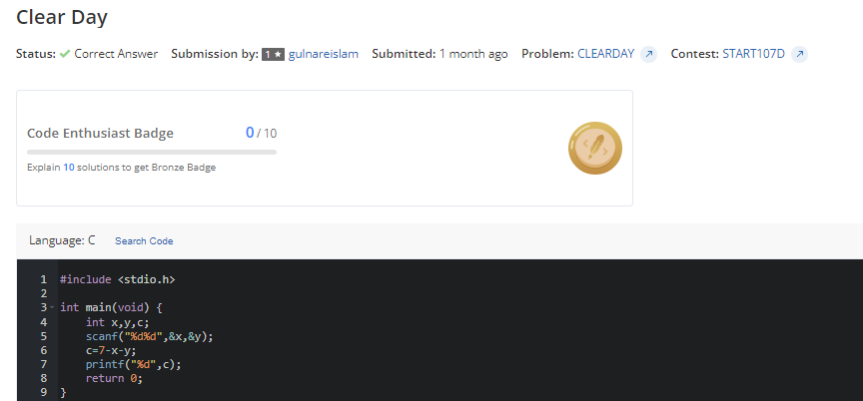

STARTERS 108 DIVISION 4(RATED)

8.RIVALRY

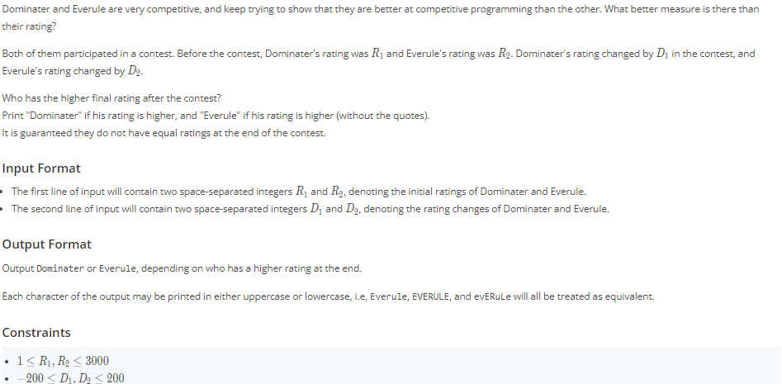

RIVALRY:

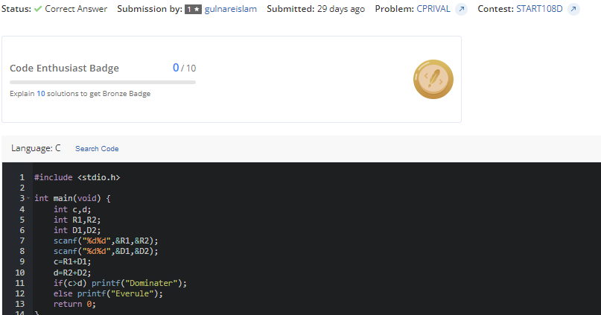

STARTERS 109 DIVISION 4(RATED)

9.CRICKED WORLD CUP QUALIFIER

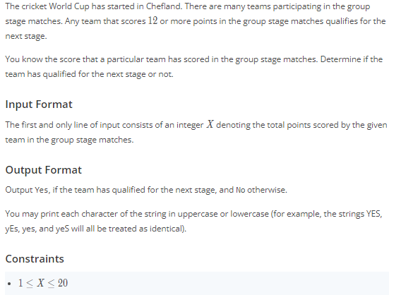

CRIDKED WORLD CUP QUALIFIER

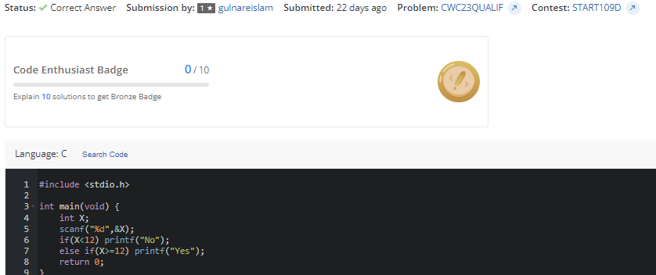

STARTERS 110 DIVISION 4(RATED)

10.WATER PARK

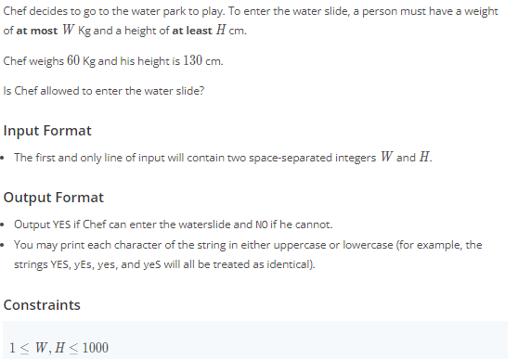

WATER PARK:

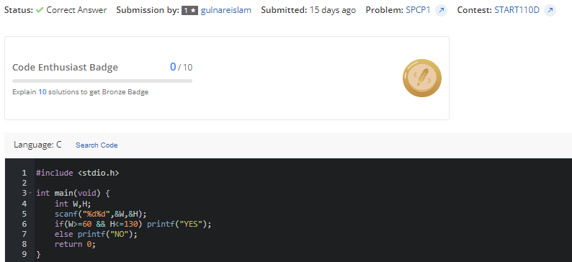

STARTERS 112 DIVISION 4(RATED)

11.FOOD COSTS

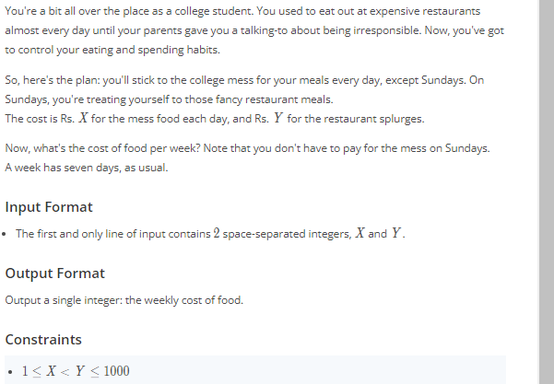

FOOD COSTS:

